Trigonometry
With Solved Problems. Illustrated.
by Frederick Hoehn, copyright 2014, all rights reserved.
Chapter 1
Trigonometry is the branch of Mathematics that deals with right triangles. A right triangle is a triangle that has a right angle. A right angle is a ninety degree angle.
If you take a piece of 8 1/2 by 11 inch paper and fold it diagonally along a line from upper left corner to lower right corner, and then unfold it, you have two right triangles, and the diagonal line is the hypotenuse of both right triangles.
The hypotenuse of a right triangle is the side opposite the right angle.
Surveyors use Trigonometry to lay out new streets, and to measure tracts of land with their exact locations.
Engineers use Trigonometry to solve engineering problems.
Trigonometry has applications in Electronics. If you look at the a.c. voltage where you live (probably 115 v.a.c.) using an oscilloscope, you’ll see a sine wave. The sine function is one of the main functions in Trigonometry.
But be sure to use a ten to one divider on your oscilloscope so you don’t damage its input.
If I know an angle of a right triangle, and you give me the length of any one of its sides, I can tell you the length of the other sides using Trigonometry.
In Figure 1, below, the ratio X/Z is the sine of angle a. No matter how large or small the triangle, that particular angle will always have the same ratio of side opposite the angle to the hypotenuse.
A second important function is the cosine function. It is the ratio of side Y to side Z. If you lengthen Y for a larger triangle, Z will also lengthen for the same angle of a right triangle.
The third important function is the tangent, which is the ratio of X/Y.

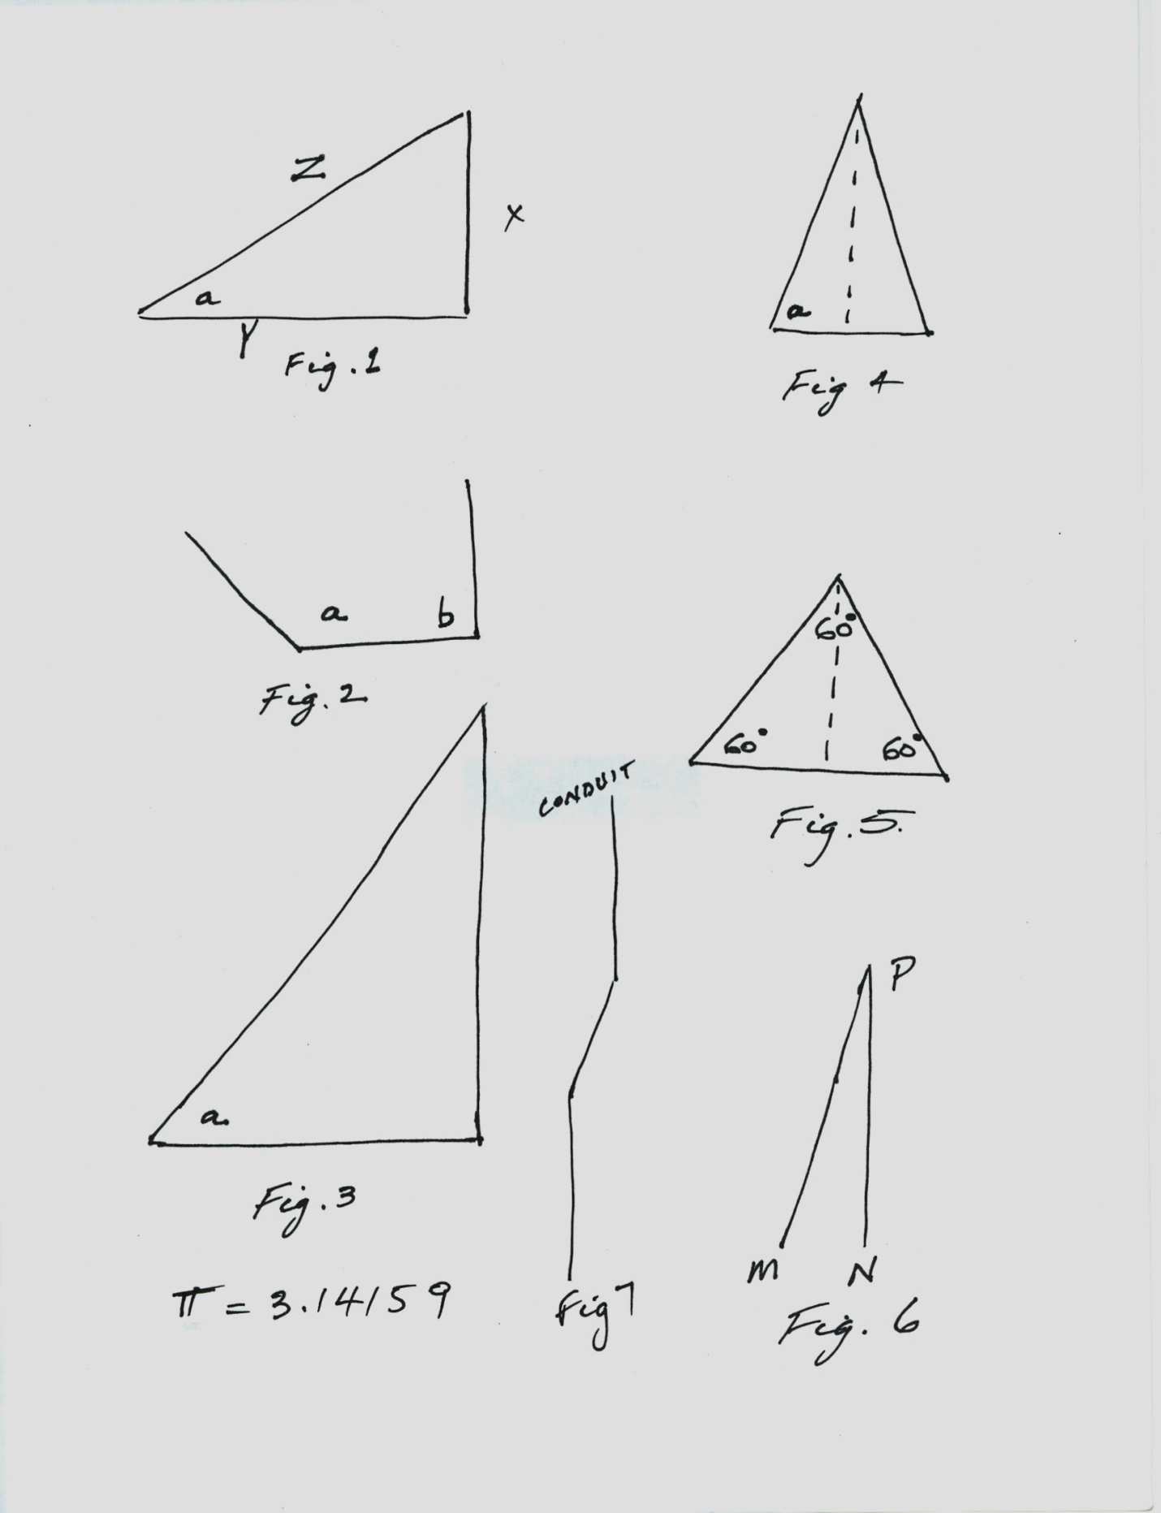
What if we have the fraction 1/5. The reciprocal of that fraction is 5.
The reciprocal of 2/3 is 3/2.
The reciprocal of the tangent is the cotangent.
The reciprocal of the cosine is the secant.
The reciprocal of the sine is the cosecant.
We abbreviate the six trigonometric functions this way: Sin a = X/Z. Sin a means the sine of angle a.
Cos a = Y/Z. Tan a = X/Y. Cot a = Y/X. Sec a = Z/Y. Csc a = Z/X.
Cot is cotangent. Sec is Secant. Csc is Cosecant.
We say that a right angle is a ninety degree angle. But another way of measuring angles that has applications in engineering and science is radians.
An angle of one radian is the angle subtended at the center of a circle by an arc equal in length to the radius of the circle. An angle of 180 degrees would be pi radians. Pi is a letter of the Greek alphabet used to mean the ratio of the circumference of a circle to its diameter.
Pi works out to about 3.14159. The Greek letter pi is shown on the drawing just below figure 3.
A 90 degree angle would be pi/2 radians.
Figure 2 shows obtuse angle a, an angle greater than 90 degrees. To the right of angle a is angle b, a right angle. We have no triangle here.
No right triangle can have an obtuse angle. For one thing, the interior angles of a triangle must add up to 180 degrees.
An obtuse angle plus the right angle already adds up to more than 180 degrees.
But take obtuse angle a in Figure 2, and make the angle smaller until it is less than 90 degrees. Now you have a right triangle, as in figure 3.
Two lines coming together make a vertex. A triangle has three vertexes and three sides.
Figure 4 represents an Isosceles triangle since it has two equal length sides.
Figure 5 represents an equilateral triangle. All three sides have the same length, and each of the three angles is 60 degrees.
A dashed line is shown in figure 4 and 5 that divides each triangle in half. Each of the halves becomes a right triangle.
The divided equilateral triangle becomes a 30, 60, 90 degree right triangle.
The sine of a 30 degree angle is one half. The side opposite the thirty degree angle is one half the length of the hypotenuse.
I’ve used that knowledge several times in bending electrical conduit.
If an offset of one foot was needed, you bend a 30 degree angle, and two feet further, you bend the conduit back straight. The length of the bent section is two feet, and the offset is one foot.
But be sure to use the right conduit bending tool. There’s one for each size of rigid conduit, and there’s one for each size of thin wall conduit (e.m.t.).
Figure 7 is a representation of a piece of electrical conduit, running mostly vertically, but bent with a horizontal offset.
When the Electrician was installing the conduit, he observed an obstruction in the path of the conduit if he had left it a straight piece of conduit. He determined that a 10 inch offset was needed in the horizontal direction.
He made his mark on the conduit where the first bend should be made. He knew that the sine of 30 degrees is ½, so he made his second mark at twice 10 inches, which is 20 inches further on the conduit.
He made his first 30 degree bend at the first mark, then, still inside the conduit bending tool, slid the conduit down to the second mark, rotating the conduit on its axis 180 degrees, so that the second bend would be back toward vertical. After the second bend, the conduit is like Figure 7.
Now the slant section of conduit is 20 inches long, and is the hypotenuse of a triangle that has the length of the offset as the side opposite a 30 degree angle, so the offset is ½ the length of the 20 inch hypotenuse. The offset is 10 inches.
The Electrician decided to make 30 degree bends because it’s easy to remember that the sine of 30 degrees is ½. But you could use many other angles for making your bends for the offset.
If you bent the conduit with 25 degree angles, then sin 25 = .423. If you want a 10 inch offset, divide 10 inches by sin 25 to get 23.66 inches for the length of the slant section.
Whatever offset you want, divide it by the sine of the bending angles to get the length of the slant section.
For a 15 inch offset with bends of 57 degrees, 15/sin 57 = 17.89 inches for the slant section.
The easy way to get the sine values is from an electronic calculator that has trig functions.
The sine of 45 degrees is .707. But instead of dividing the offset by .707, you could multiply the offset by csc 45, which is 1.414.
You could work this out yourself by drawing a square, and using the Pythagorean Theorem.
Take your square and draw a diagonal line from one corner to the opposite corner. All four sides of a square have equal length. All four of its angles are 90 degrees.
Your diagonal divides the square into two 45 degree right triangles, and the diagonal is the hypotenuse of both triangles.
If the length of the side of the square is one unit, the formula is a squared plus b squared equals c squared. So, 1 plus 1 equals 2, and the diagonal is the square root of 2, which is 1.414, which is also the cosecant of 45 degrees, while its reciprocal, .707 is the sine of 45 degrees.
The square root of a number is the number which when squared yields the original number.
The square root of 25 is 5, because, when you multiply 5 by itself, you get 25.
A Carpenter friend of mine asked if there’s a way to determine the length of the slant piece on a roof if the vertical and horizontal lengths are known.
I told him he could do it with trigonometry or with the Pythagorean Theorem. In Figure 1, the Pythagorean Theorem would say that X squared plus Y squared is equal to Z squared.
Any number squared is just the number multiplied by itself. To the upper right of the variable that is squared, we would write a small 2 as the “exponent”.
So if you’re the carpenter, you can square the vertical length, and add to the square of the horizontal length, and then press the square root button on your calculator to find the length of the hypotenuse.
But many roofs have an overhang, so remember to add the length of the overhang. Also, the first few times you cut the length of the slant piece, better add an extra couple inches because unlike lines on the paper, two by fours also have width and depth.
It’s easier to cut off a little than to put it back if you’re too short on the length.
But to use trigonometry, it’s a two step process to figure the length of the roof slant piece. First get angle a from its tangent, the ratio of vertical to horizontal.
Let’s say your vertical is four feet, and your horizontal is ten feet in the triangles you are building to make the slanted roof. Let’s find angle a in Figure 1 for this problem.
So, Tan a = 4 feet/ 10 feet.
On the calculator, press and release shift, and then tan. This gives us the arctan function. The arctan function asks what is the angle with the tangent of a certain number (in this case 4/10).
Press shift, tan, and enter 4 / 10, press right parenthesis, and then equals, and we get 21.8 degrees.
Now, just to prove that, after clearing, we press tan (21.8) = , and we get .39997, pretty close to 4/10.
Note that the calculator is set up to do degrees. You could also set it to do radians instead of degrees. Check the manual on your calculator.
On my Casio fx 300 PLUS, you press shift, mode, and then either the 3, or 4, or 5, for degrees, radians, or grads.
Having obtained the angle using its tangent, then find out what the cosine of that angle is. The cosine of 21.8 degrees is .9285 which equals Y/Z.
To find the length of Z, the hypotenuse, we divide ten feet by the cosine of 21.8 degrees and get 10.77 feet.
Then, add your overhang.
After you get those slant pieces on, plywood goes over that, a layer of tar paper, and then roofing material such as shingles.
Here’s another example: The vertical is 3 ½ feet, and the horizontal is 12 feet. How long a slant?
Solution: Arctan (3.5/12) = 16.26 degrees. 12 feet divided by cos (16.26 degrees) = 12.5 feet (plus any overhang).
Chapter 2
Figure 6 represents an airplane directly over a city at location N. As the pilot looks down at that angle with the vertical, he can see another city at location M.
If we say the pilot is at an altitude of 30,000 feet, and the angle is 42 degrees, then what is the distance MN between the two cities?
Although the figure doesn’t show a line from M to N, draw that line in your mind, and you have a right triangle. Since the airplane is directly over the city at N, N is therefore the vertex of the right angle of the right triangle. The length MN divided by the altitude of 30,000 feet is the tangent of 42 degrees.
Of course, if we were talking about long distances, the curvature of the earth would come into it. But for this problem, assume a flat earth.
Now we use our pocket electronic calculator to find the tangent of 42 degrees. The tangent of 42 degrees is approximately 0.9. Now multiply that tangent by 30000 feet, and you get 27012.121 feet.
But one mile is 5280 feet. So we divide this last number by 5280, and we get 5.12 miles as the distance MN between the two cities.
You can graph trigonometric functions. Along the x axis, mark your degrees, perhaps in ten degree steps. Then for y values, use your sine or cosine or tangent for your degree values.
The sine function will plot to a sine wave like we see in electronics.
These arcsin, arccos, and arctan functions are called “inverse trigonometric functions.”
Instead of asking for the sine of an angle, we’re asking what is the angle for a certain number that is the sine of an angle.
If s = sin B, then B = arcsin s.
If c = cos B, then B = arcsin c,
If t = tan B, then B = arctan t.
Another way of writing arcsin s, is to write sin to the minus 1 exponent of s. (An exponent of -1).
Another topic usually covered in Trigonometry is Polar Coordinates. Instead of giving the x and y coordinates, we can give an angle and a distance, r, from the intersection of the X and Y axes.
To convert from points x, y to polar coordinates, the angle would be arctan (y/x), and the distance, r, is the square root of (x squared + y squared).
To convert from polar coordinates to rectangular coordinates, x = r cos a (the angle), and y = r sin a.
But the helmsman of a ship uses different angles. Zero degrees is North, not East. If he steers a course of 270 degrees, he’s heading West.
The cosecant, secant, and cotangent functions aren’t used as much as sine, cosine and tangent functions. Just remember the reciprocal definitions given earlier in the book.
I stopped by Walmart the other day to get some groceries, and I found a Casio calculator for ($12.47) plus tax that does the trigonometry functions.
Getting my education, there was a course that had a textbook, and then we also had the “CRC Standard Math Tables.” CRC stands for Chemical Rubber Company.
So you could look up your logarithms and sines and cosines in the math tables.
But now, for not very much money, you have pretty much all of that information in a calculator, thinner than a TV remote control.
And the information is a lot easier to access with the calculator, instead of thumbing through the math tables. Enter a few numbers, press a few keys, and you have your answer.
But if you take a math course (or engineering or science) ask whether you’re allowed to use your calculator. If you are allowed, it surely makes life easier.
Another manufacturer of calculators is Texas Instruments.
Problem: A lighthouse keeper stands in the lighthouse and sees below in the ocean a piece of debris that could be part of a missing airplane. If the man’s eyes are 225 feet above sea level, and his viewing angle with reference to the horizontal is 30 degrees, how far away from the base of the lighthouse is the piece of debris?
Solution: tan (30 degrees) = .577 = 225 feet/X. Solving for X, X = 225/tan(30) = 389.7 feet.
In Trigonometry, we have what are called “Identities.” These identities help us manipulate equations in trigonometric problems.
Here are some Trigonometry identities:
Sin a = 1/csc a
Cos a = 1/sec a
Tan a = 1/cot a
Tan A = sin A/cos A
Cot A = Cos A/sin A
Sin (-A) = -(sin A)
Cos (-A) = cos A
Tan (-A) = -(tan A)
Pi = 3.14159
Figure 2 shows rectangular coordinates and some angles and triangles. Quite often, we do trigonometry without the rectangular coordinates, or if we use them at all, we mostly use just the first quadrant, shown as upper right.
The quadrants are labeled in Fig. 2 as # I, II, III, and IV, using Roman Numerals.
Some engineering applications will use angles larger than 90 degrees. As you can see in quadrant II, there is an angle that is called a 150 degree angle because, measured from the positive x axis it’s 150 degrees.
That angle is part of a triangle. But that triangle is still a 30, 60, 90 degree right triangle. The 150 degree name just shows us that it’s over in the second quadrant.
The 210 degree angle is in the third quadrant, but the triangle is still your 30, 60, 90 degree right triangle.
Similarly for the 330 degree angle in the fourth quadrant.
So these are just basically some definitions that you may have use for in some of the Engineering courses.

